# PRACTICE PROGRAMS MODULE -1

## SECTION:5

### SECTION-5.1

1A)

PROGRAM :

public class Main {

public static void main(String[] args) {

int x = 5; // test value

boolean result = (x <= 7) ? true : false;

System.out.println("Is x less than or equal to 7? " + result);

}

}

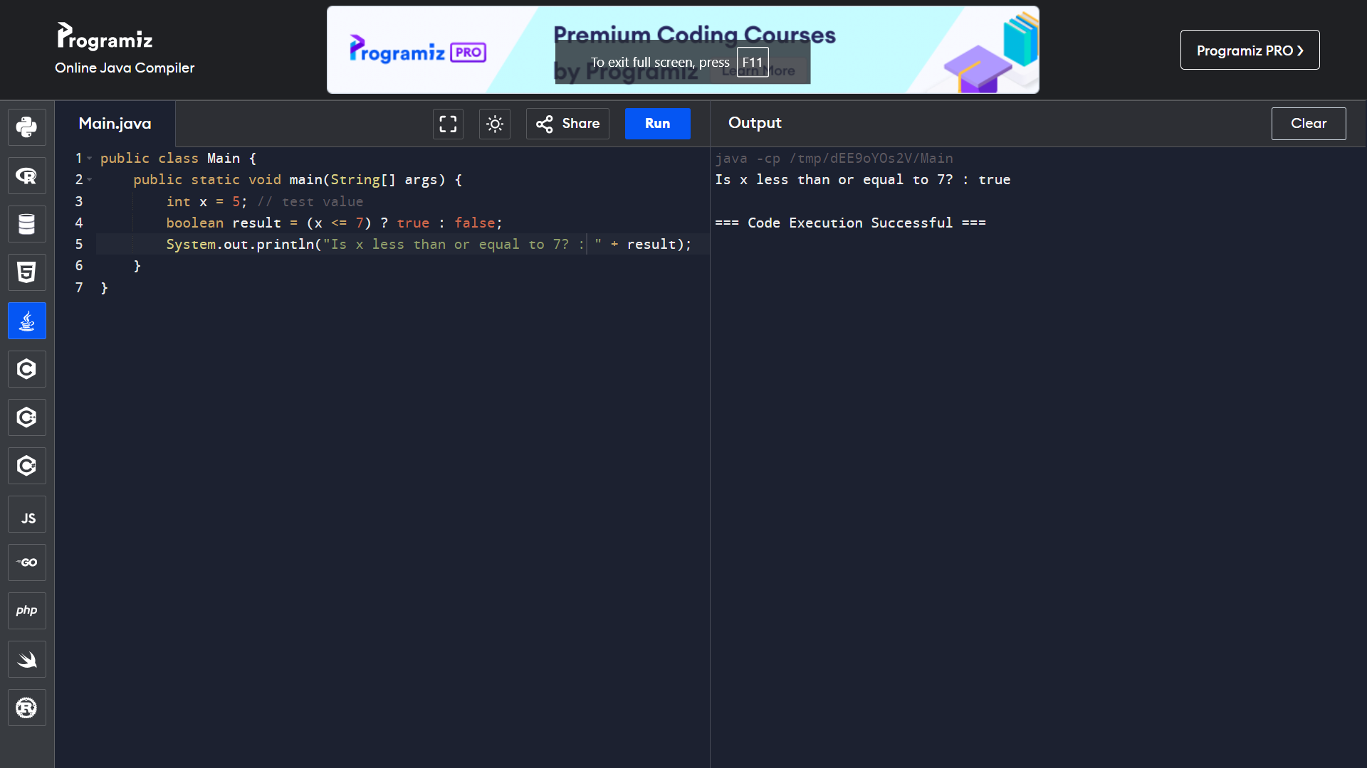

2A)

PROGRAM :

SWITCH CASE :

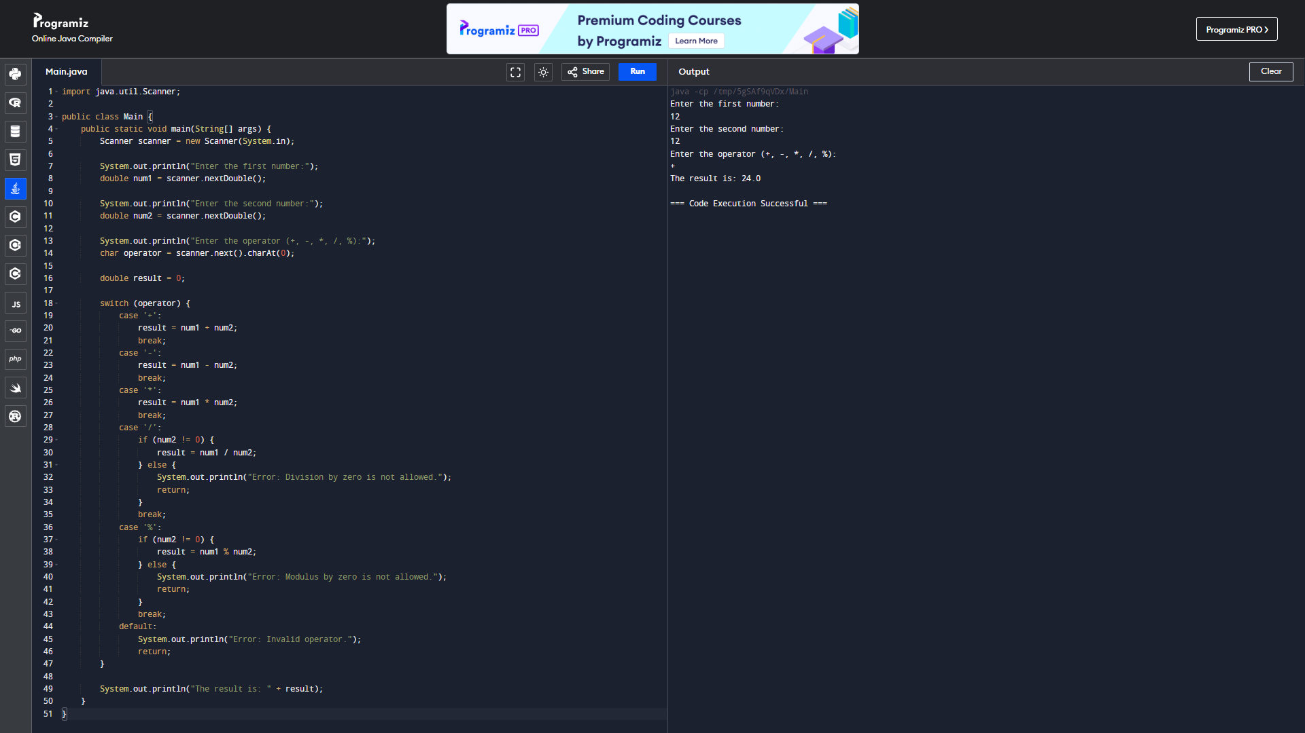

IF / ELSE :

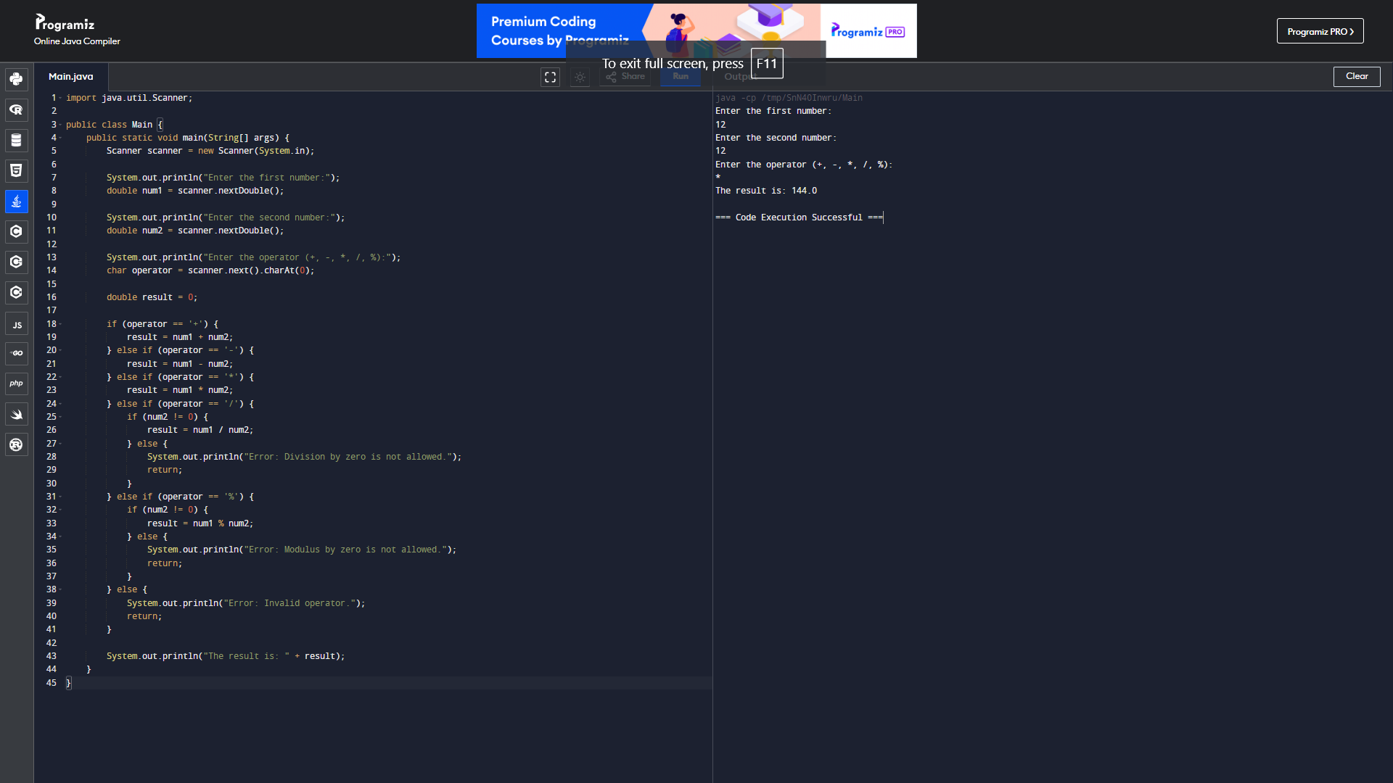

4A)

PROGRAM :

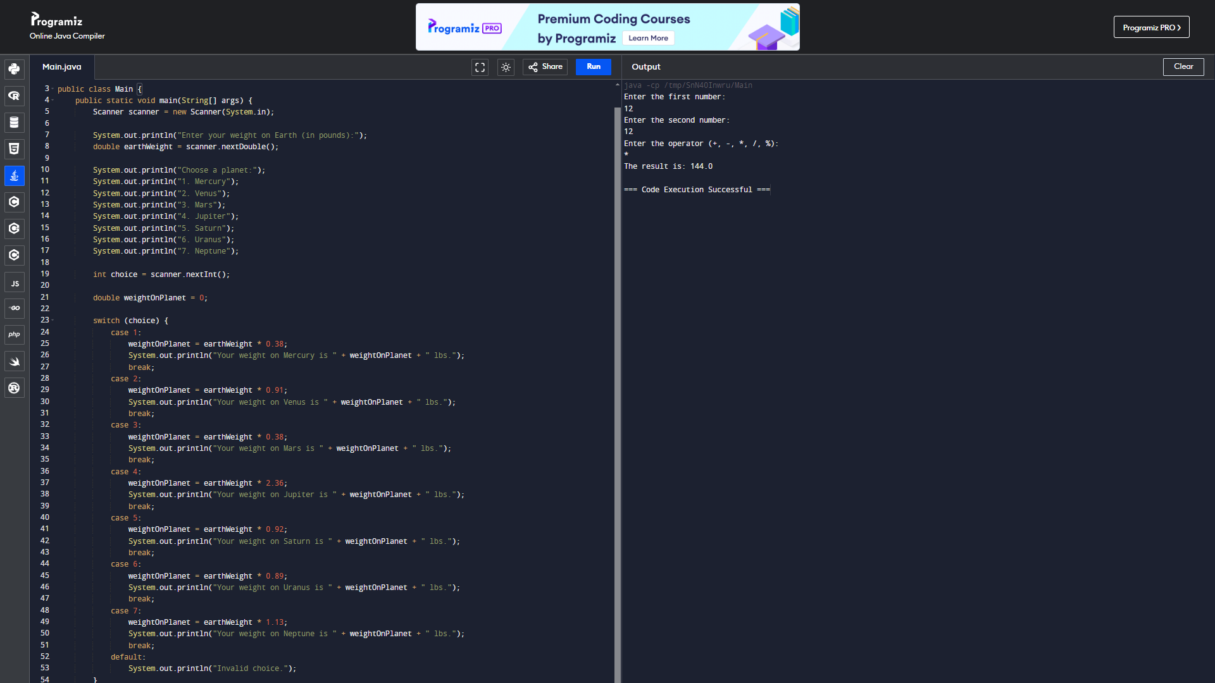

5A)

PROGRAM:

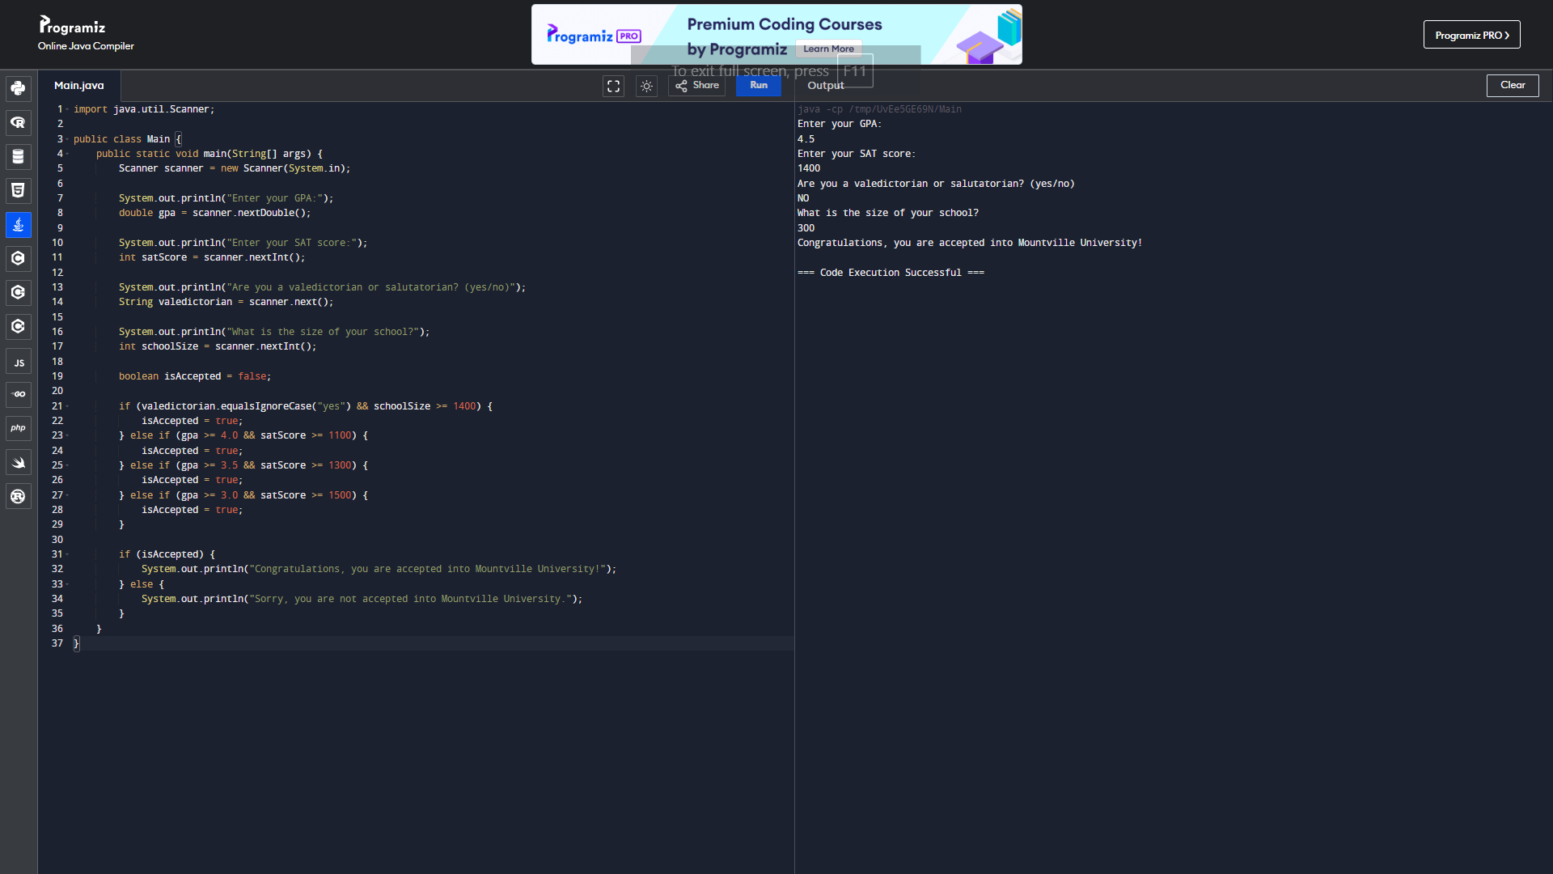

6A)_

PROGRAM:

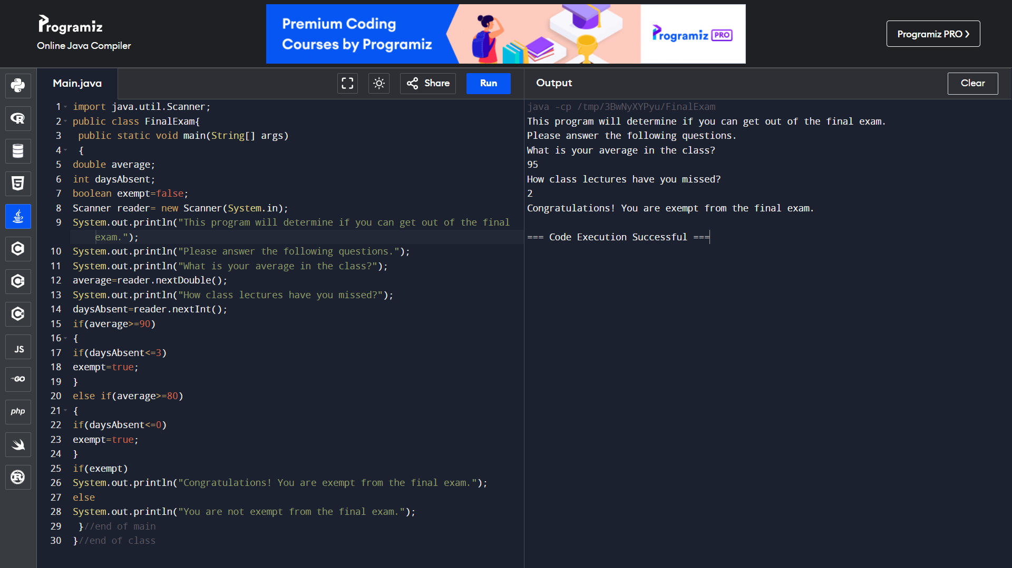

7A)

PROGRAM:

